Fantastic People Videos Activity Booklet

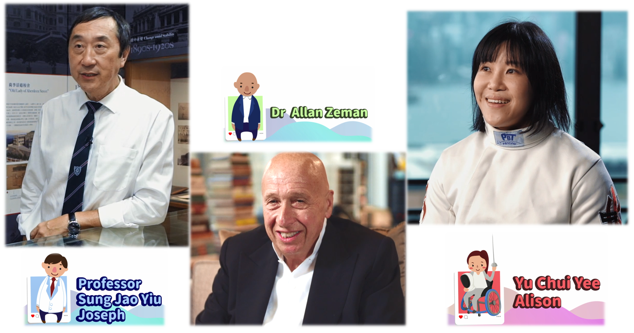
© English Language Education Section
Curriculum Development Institute
Education Bureau
HKSAR, 2021
All rights reserved

(Blank Page)

English Language Education Section
Curriculum Development Institute
Education Bureau
The Hong Kong Special Administrative Region

12/F, Wu Chung House, 213 Queen’s Road East, Wan Chai, Hong Kong

Published 2021

The copyright of the materials in this resource kit belongs to the Education Bureau of the Hong Kong Special Administrative Region.

Duplication of materials in this resource kit is restricted to non-profit-making educational purposes only. In all cases, proper acknowledgements should be made. Otherwise, all rights are reserved, and no part of these materials may be reproduced, stored in a retrieval system, or transmitted in any form or by any means without the prior permission of the Education Bureau of the Hong Kong Special Administrative Region.

© 2021

(Blank Page)

Contents

Preface |  | i
Acknowledgements |  | iii
Part 1 | An interview with Professor Sung Jao Yiu Joseph | 1
 | - Activity sheets | 3
 | - Quotes | 9
Part 2 | An interview with Dr Allan Zeman | 13
 | - Activity sheets | 15
 | - Quotes | 20
Part 3 | An interview with Ms Yu Chui Yee Alison | 23
 | - Activity sheets | 25
 | - Quotes | 30
Part 4 | Suggested answers | 33

(Blank Page)

Preface

Fantastic People Videos Activity Booklet is developed by the English Language Education Section, Curriculum Development Institute, Education Bureau, in support of the learning and teaching of English Language at primary level. To provide localised materials for teachers on introducing the themes “We love Hong Kong” and “Special people”, a series of videos on “Fantastic People” has been produced to introduce three celebrities – Professor Sung Jao Yiu Joseph, Dr Allan Zeman and Ms Yu Chui Yee Alison to primary school students in Hong Kong through the interviews with them in the videos. Students will be able to learn from their sharing and gain insights into their life experiences, achievements and beliefs. In this connection, Fantastic People Videos Activity Booklet is developed to facilitate and complement the use of the videos in promoting positive values and attitudes in the English Language classroom through understanding the achievements and contributions of the celebrities.

Aims of the Activity Booklet
This booklet aims to:
- complement the Fantastic People videos by providing suggestions on how to effectively use the videos to guide students to learn from the sharing of the famous people and inspire students to pursue their dreams and goals;
- develop students’ language skills, including viewing skills through appreciation of the videos; and
- reinforce the development of positive values and attitudes, e.g. optimism, perseverance, commitment and caring for others, through appreciating and reflecting on the success stories in the videos.

Suggested Levels
Key Stage 2 (Primary 4 to 6)

Content of the Activity Booklet
This booklet consists of three sets of learning and teaching materials developed for the Fantastic People videos. Each set of materials comprises pre-viewing, viewing and post-viewing activities to guide students to better understand the success stories of the celebrities (e.g. background, challenges, achievements) and appreciate images in the videos and the messages delivered by the celebrities. These help cultivate positive values and attitudes through inspiring students to reflect on the sharing in the videos and write about their own dreams and goals. An overview of quotes is also provided to facilitate teachers’ introduction of the positive messages in the English lessons.

Using Fantastic People Videos Activity Booklet in the English Lessons
Schools are encouraged to make effective use of this activity booklet, integrating into the relevant modules and themes in the school-based English Language curriculum as appropriate, to enrich students’ English learning experiences, nurture their positive values and attitudes and inspire them to pursue their dreams and goals. Teachers are encouraged to select and adapt the materials to suit their students’ needs, interests and abilities.

This activity booklet and videos are available on the website of the Education Bureau (http://www.edb.gov.hk/Fantastic_People) and the website of Educational Multimedia (EMM) (https://emm.edcity.hk/playlist/1_hea30nj2/1_gjbkgroh).

The website of the Education Bureau
The website of Educational Multimedia (EMM)

Acknowledgements

Our deepest gratitude is extended to Professor Sung Jao Yiu Joseph, Dr Allan Zeman and Ms Yu Chui Yee Alison for spending their invaluable time on the interviews for the production of the videos on “Fantastic People”.

(Blank Page)

Part 1

An Interview with
Professor Sung Jao Yiu Joseph

(Blank Page)

(Pre-viewing)

Part A: Making predictions about the character
1. You are going to watch an interview and know more about Professor Sung Jao Yiu, Joseph. Have you heard of him before? Look at the picture below.

What is Prof Sung wearing?

What is his job?

Professor Sung

What does he do in his job?

2. List three qualities a person needs in order to be a doctor:

(Viewing)

Part B: Understanding the background and achievements of Prof Joseph Sung
3. Watch the video and complete the chart below.
Prof Joseph Sung

Education

- Studied at Q__________C_________
- Liked Physics because the __________ were fantastic
- Liked ____________because it was interesting to do little dissections, such as dissecting _______________, rats and also cockroaches.
Achievements

_____ Graduated from a medical school.

2002 Achieved groundbreaking discovery of using an __________________ to cure Helicobacter pylori infection in the stomach

2003 Hailed as an “_______ ______” by Time Magazine for his contribution during the epidemic

Quotes

- “Becoming a doctor, looking after the poor and the sick, is the part of my career that I’m most ___________ of.”
- “Challenge means that you go into uncharted waters, but this is the time that you will learn new ___________.”
- “There is no shortcut to success. _________ _________ will bring you success.”
2004 Awarded ___________Bauhinia Star
_________________

- In Year 2003, a disease called _______ hit Hong Kong. In the period of six months, doctors and patients faced life-and-death situations. Prof Sung provided the medical staff with all the necessary protection before sending them into the war zone. He also faced the challenges with his teammates.
(Post-viewing)

Part C: Self-reflection

4. Why did Prof Sung like to be a doctor the most?

_________________________________________________
_________________________________________________
_________________________________________________

5. According to Prof Sung, what does challenge mean?

Challenge means going into uncharted waters. __________________
________________________________________________________
________________________________________________________
However, it is the time that we will learn new lessons. ____________
________________________________________________________

6. What have you learnt from Prof Sung?

I have learnt from Prof Sung that if I want to achieve my goal, ____________________________________________________
____________________________________________________
I have also learnt that when there is a challenge, _____________
_____________________________________________________
7. You have seen Prof Sung visiting his alma mater. In your opinion, how does Prof Sung feel towards his alma mater? Refer to the images below and share your ideas.

 | 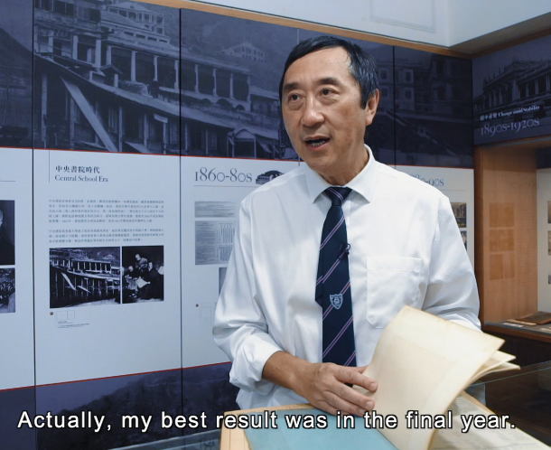 | 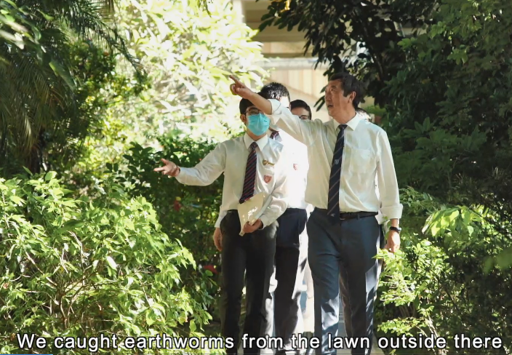
 | (Image taken from the video: 1:05)  Prof Sung is showing his school report. | (Image taken from the video: 1:29)  Prof Sung is walking and chatting with some students on the school lawn.
 | 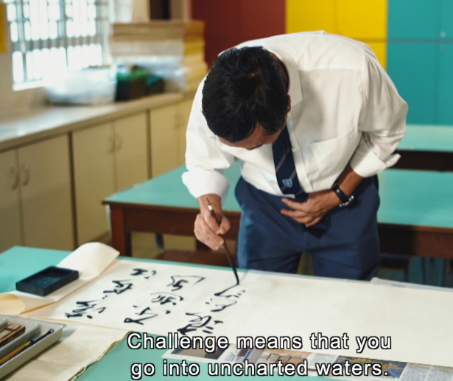 | 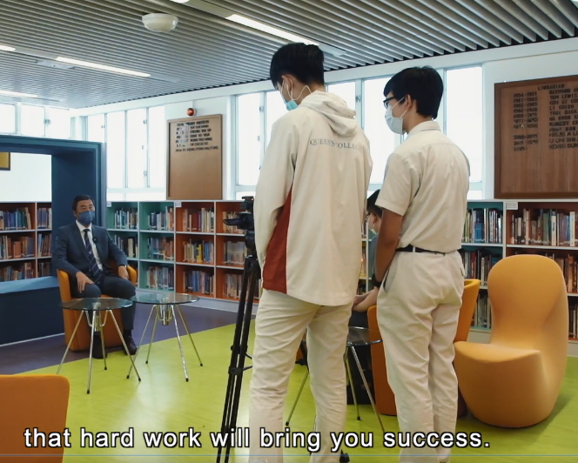
 | (Image taken from the video: 4:00)  Prof Sung is demonstrating Chinese calligraphy. | (Image taken from the video: 5:49)  The students are interviewing Prof Sung.

8. Prof Sung brought us to Prince of Wales Hospital and we could see him at work. Moreover, he has many great achievements. What do you think of Prof Sung? Refer to the images below and share your ideas.

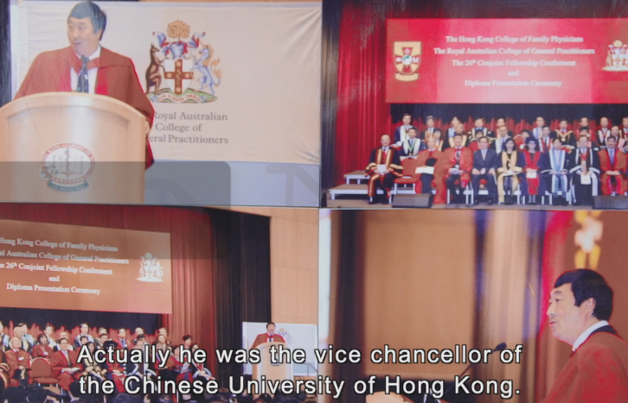 |  | 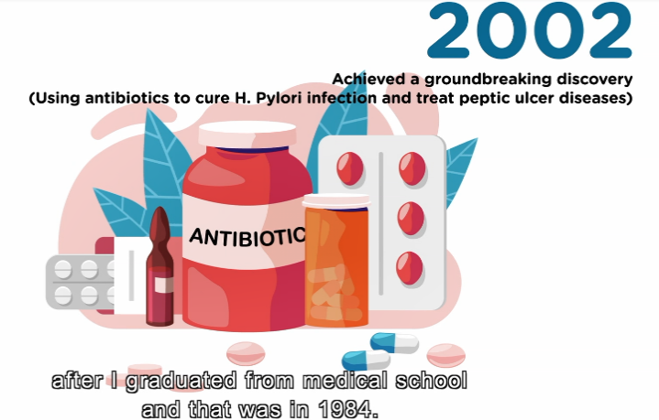
(Image taken from the video: 1:48)  Prof Sung was the Vice-chancellor and President of the Chinese University of Hong Kong. |  | (Image taken from the video: 2:22)  His groundbreaking discovery of treating Helicobacter pylori infection and peptic ulcer diseases.
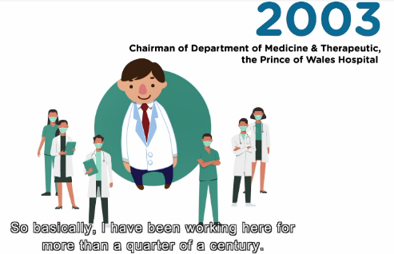
(Image taken from the video: 2:26)  He led a team of medical staff to fight the SARS epidemic in 2003. |  | (Image taken from the video: 2:31)  He was awarded the Silver Bauhinia Star in 2004.
9. Prof Sung is now working at Nanyang Technological University in Singapore. Write a card to send your greeting and express your gratitude to him in 80 – 100 words.
The greeting:  (e.g. I’m a primary five student studying at ABC School. I’m writing to send my best wishes to you.) | The part(s) of the video that touched you most:  (e.g. I’ve watched a video about you recently and your sharing about how you faced challenges touched me most.)
Your gratitude to Prof Sung  (e.g. I’d like to thank you for your sharing and encouragement to youngsters.) | The positive messages you have learnt from  Prof Sung:  (e.g. I’ve learnt that I should face difficulties with courage and diligence.)

Quotes from Professor Sung Jao Yiu Joseph
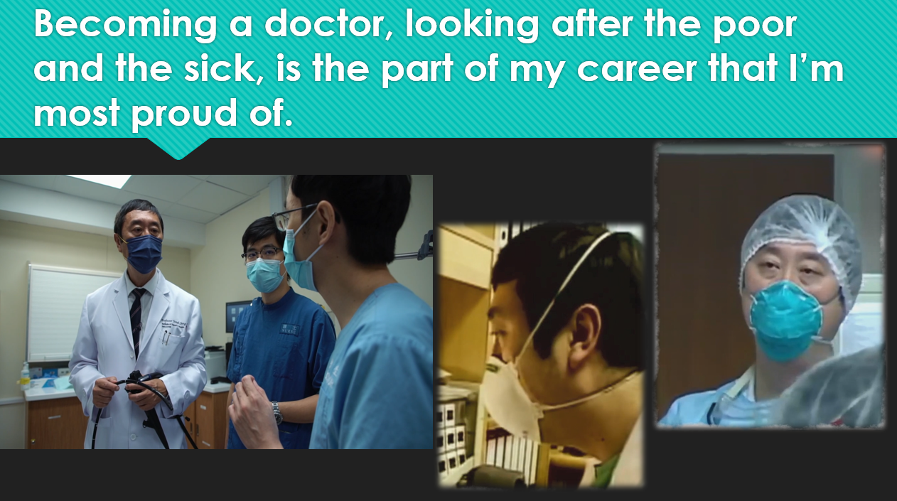
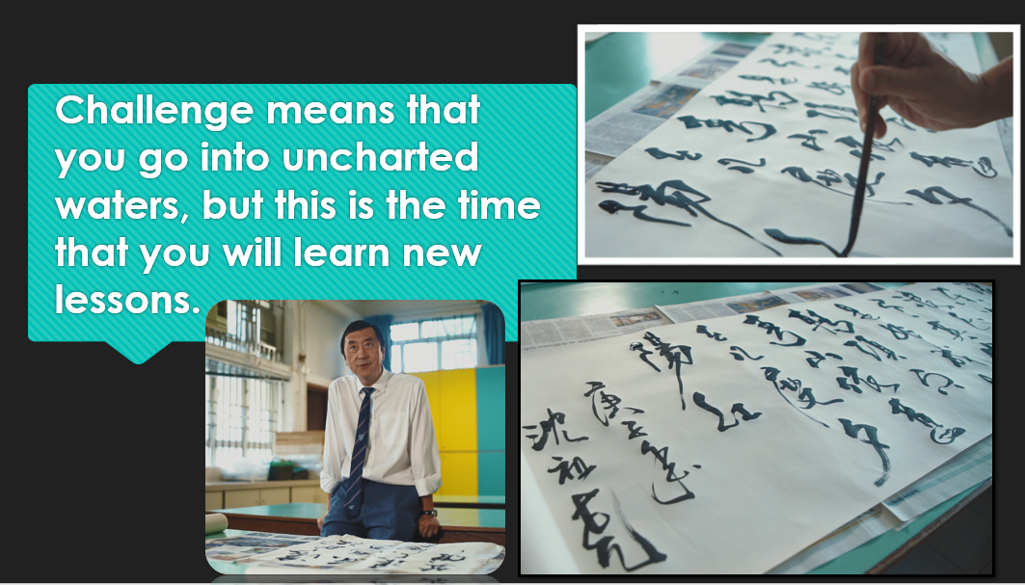
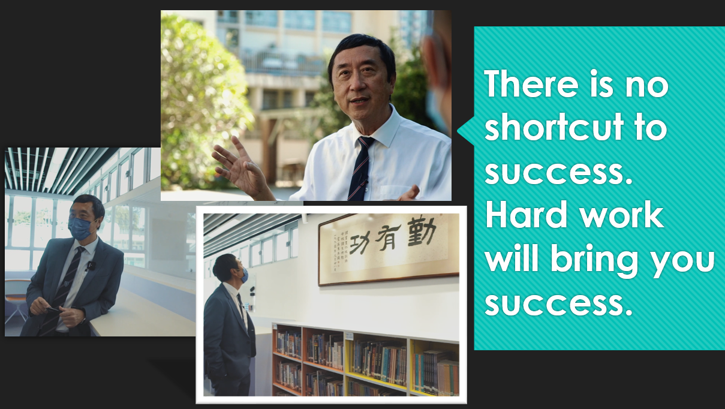

(Blank Page)

Part 2

An interview with
Dr Allan Zeman

(Blank Page)

(Pre-viewing)

Part A: Making predictions about the character
1. You are going to watch an interview and know more about Dr Allan Zeman. Have you heard of him before? Look at the picture below.

What is Dr Zeman wearing?

What is his job/career?

Dr Zeman

What does he do in his job/career?

2. List three qualities a person needs in order to be a businessman/an entrepreneur:

(Viewing)

Part B: Understanding the background and achievements of Dr Allan Zeman
3. Watch the video and complete the chart below.

Dr Allan Zeman
Early Life

7 years old: Dr Zeman’s ___________ died
19 years old: went to Hong Kong and made a _____________ US dollars profit
16 years old: bought his own _________
12 years old: worked in a ______________ cleaning tables
10 years old: delivered ______________ before school

Achievements

- Awarded the ___________ Bauhinia Star in 2004
- Awarded the ___________ Bauhinia Medal in 2011

(Post-viewing)
Quotes

- “Don’t just look at what you see. Think __________. Think how this can be a success.”
- “A successful entrepreneur is someone who is __________________, has _____________ dreams and makes the dreams a ____________.”
- “Always look ____________ and then bring everybody along with you. Be approachable. I’m everybody’s _____________.”
Challenges

- Became the _____________ of Ocean Park
- Ran around the world, looked at different ___________ and looked at ___________
- Figured out how to make Ocean Park _________________ with the designers
- Kept the park open while _____________ the park
- Changed all the ______________ for all the staff

Part C: Self-reflection

4. What does ‘success’ mean to Dr Zeman?

- Success is having an _________, having a _________, looking at something and then making it a _____________.
- Doing something that you really have a _____________ for.
- There are opportunities for everyone as long as you use your _________ and as long as you follow your _____________.

5. According to Dr Zeman, what are the qualities of a successful entrepreneur?

- You need to have _________________ in yourself.
- Don’t look at things for what they are. Look at things for __________________________________________.
- Think _____________. Think how you can make this into something ______________.
6. What does ‘success’ mean to you? Do you have any dreams?

7. Dr Zeman is a successful entrepreneur and has been awarded the Gold Bauhinia Star and the Grand Bauhinia Medal for his contributions to Hong Kong. What are the factors that make him so successful? Refer to the images below and share your ideas.

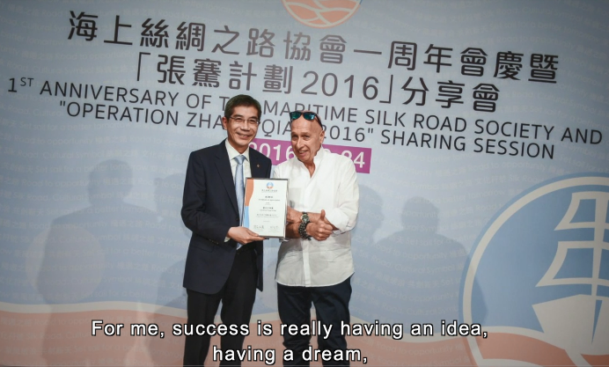
(Image taken from the video: 0:41)  Dr Zeman shares how to become a successful person. |  | (Image taken from the video: 1:29)  Dr Zeman is talking about his early life in Canada.
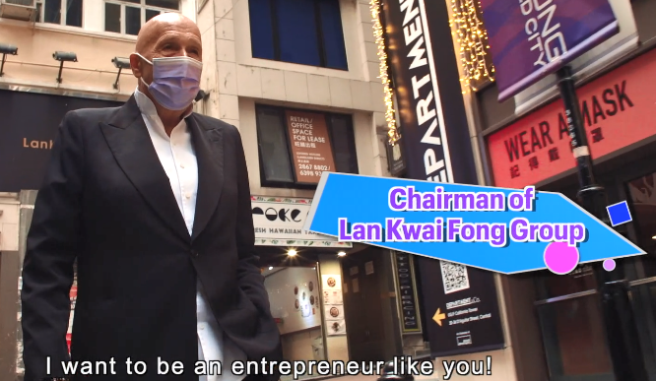 |  | 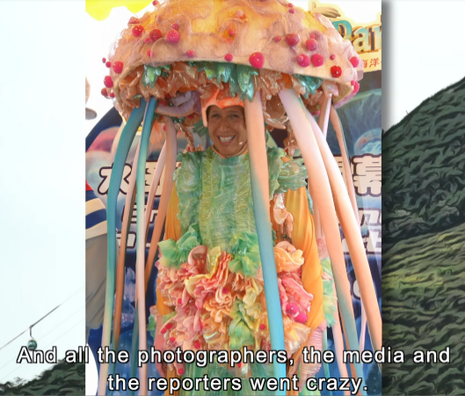
(Image taken from the video: 3:39)  He is talking about his business in Lan Kwai Fong. |  | (Image taken from the video: 5:45)  Dr Zeman is in a jellyfish costume to promote Ocean Park.
8. What do you want to do in the future? What is your dream job? Write about your dream job in 80 –100 words. Share it with your classmates.
What is your dream job? Why do you like this job?  (e.g. I want to be a vet in the future because I love animals.) | What do you need to do?  (e.g. I have to diagnose the illnesses of different types of animals, and I may have to do surgery for them.)
What will you do to achieve your goal?  (e.g. To achieve my goal, I will have to work hard and read more books and information about animals, e.g. on animal care, illnesses and treatment.) | What qualities does a person need to have in order to be successful in that area?  (e.g. To be a successful vet, I need to be kind-hearted and knowledgeable.)
_________________________________________________________________
_________________________________________________________________
_________________________________________________________________
_________________________________________________________________
_________________________________________________________________
_________________________________________________________________
_________________________________________________________________
_________________________________________________________________
_________________________________________________________________
_________________________________________________________________
_________________________________________________________________
_________________________________________________________________
_________________________________________________________________
_________________________________________________________________

Quotes from Dr Allan Zeman
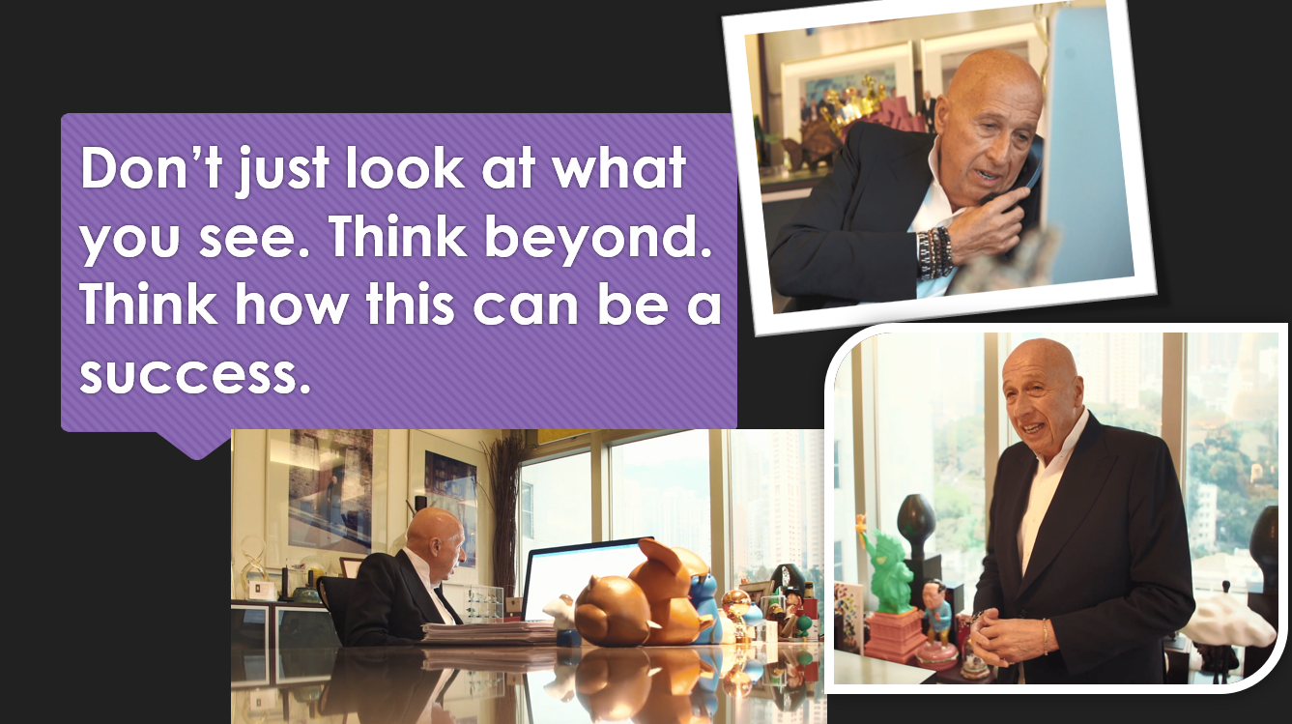
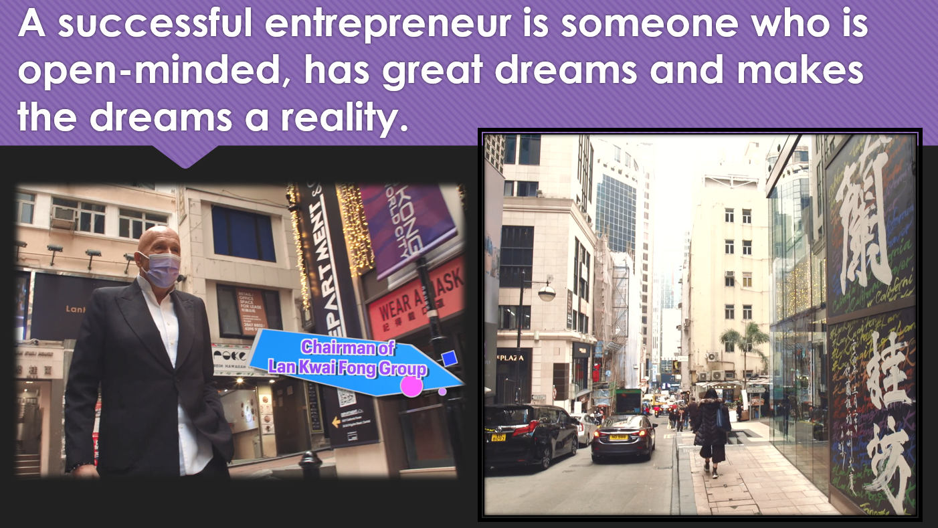

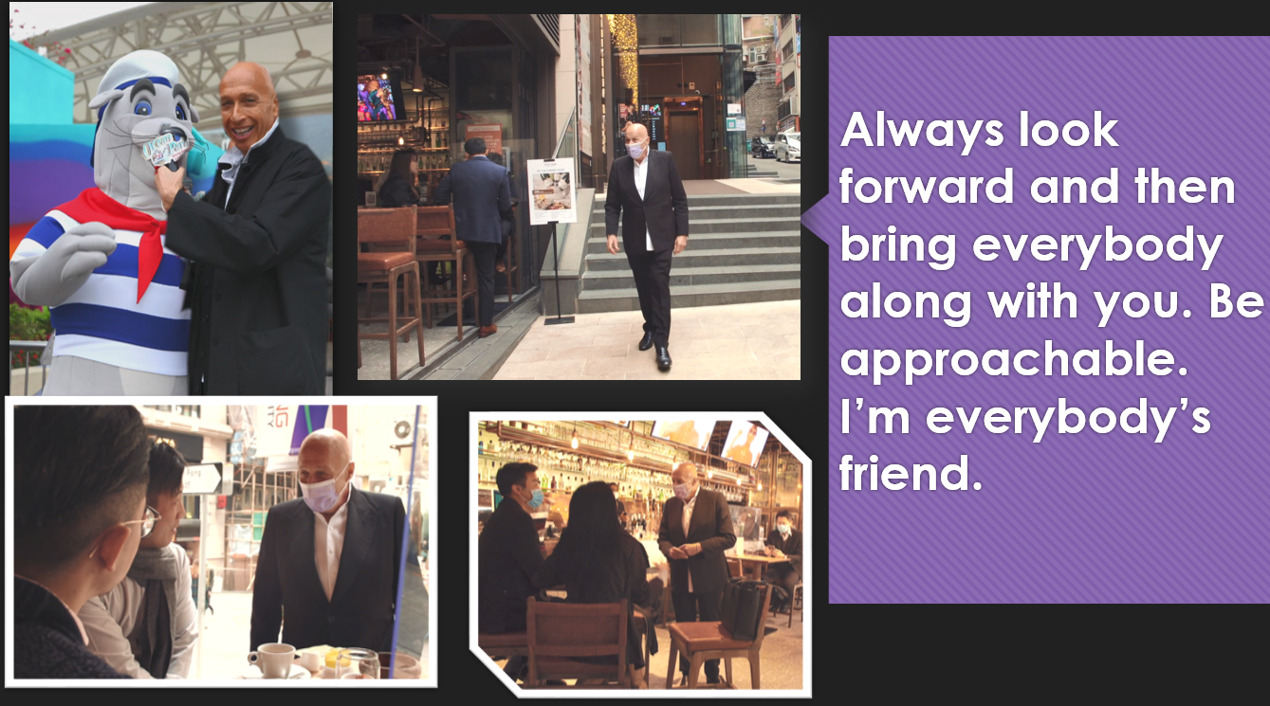

Part 3

An Interview with
Ms Yu Chui Yee Alison

(Blank Page)

(Pre-viewing)

Part A: Making predictions about the character
1. Look at the picture below. Have you heard of Ms Yu Chui Yee, Alison? Can you guess what is very special about her?
Why does she sit in a wheelchair?

What sports does Alison play?

What is her job?

2. List three qualities a person needs in order to be an athlete:

(Viewing)

Part B: Understanding the background and achievements of Ms Alison Yu
3. Watch the video and complete the chart below.

Achievements

- Awarded the _______________ Bauhinia Star
- Received Hong Kong Sports Stars Award ________ times
- Won ________ Paralympic medals

Childhood

- Loved _______________ , e.g. playing badminton and swimming
- Got ____________________ when she was 11 years old

Ms Alison Yu
Quotes

- “It’s okay __________ to be okay. If you don’t really experience the ______________, you don’t know what happiness is.”
- “I would like to say ‘____________ ______’ to the cancer because without that, I don’t think I can be a Paralympian.”
- “You can always find a way to _____________ your obstacles.”
Challenges

- Got ____________________________
- Had to amputate her ______________
- Learn to be friends with the __________________

Ways to release stress

- _____________ something good
- Doing ____________
- Listening to ____________

(Post-viewing)

Part C: Self-reflection

4. What adjectives would you use to describe Alison? Why? (e.g. optimistic, positive, out-going, cheerful, etc.)

5. What have you learnt from Alison?

6. We face different challenges every day and may feel stressful sometimes. It is important to find ways to release our stress.
a) Tick the challenges that you are facing.
b) Write down the things you do to help you release stress in the balloons below and share them with your classmates.
parents’ expectation
school work
friendship
competitions
examinations

illnesses

To help me release my stress from the examinations, I will do some exercise.

7. Being a professional athlete requires years of disciplined practice, as well as perseverance and determination. In your opinion, what makes Alison such a fantastic person? Refer to the images below and share your ideas.
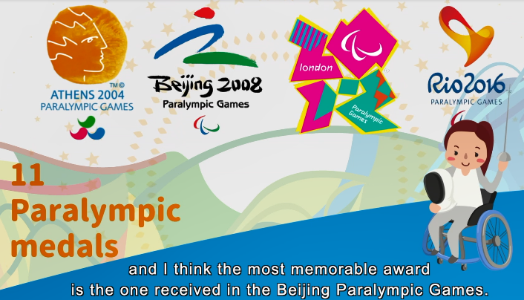 | 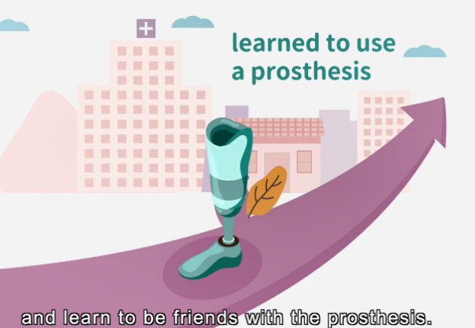
(Image taken from the video: 0:53)  Alison received Hong Kong Sports Stars Awards seven times and won 11 Paralympic medals. | (Image taken from the video: 2:27)  She had bone cancer at 11 years old and had to amputate her left leg.
 | 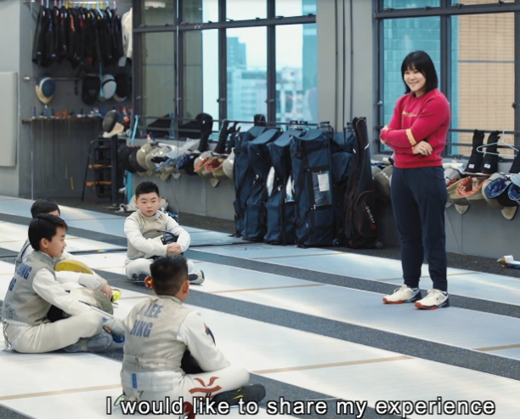
(Image taken from the video: 4:13)  She shared her life motto that “It’s okay not to be okay”. | (Image taken from the video: 5:30)  She shared that when she retired, she would try to contribute more to the Paralympic movement and to Hong Kong society.

8. What made you feel very stressful? How did you cope with stress? How did you feel at last? What have you learnt from the experience? Think of one incident and write a journal in 80-100 words.
What made you feel stressful?  (e.g. The badminton competition made me very stressful.) | How did you cope with stress and solve the problem?  (e.g. To cope with stress, I listened to music and talked to my friends. I also set a reasonable timetable and practise more.)
What have you learnt from the experience?  (e.g. I have learnt that I have to find ways to release my stress. Also, I found that stress can be the driving force which motivates me to do better.) | How did you feel at last?  (e.g. I felt relaxed at last.)

Journal Writing
Date: ____________________
Weather: ____________________
Topic:
Ways to cope with stress:
_________________________________________________________________
_________________________________________________________________
_________________________________________________________________
_________________________________________________________________
_________________________________________________________________
_________________________________________________________________
_________________________________________________________________

My drawing/notes:

Quotes from Ms Yu Chui Yee Alison
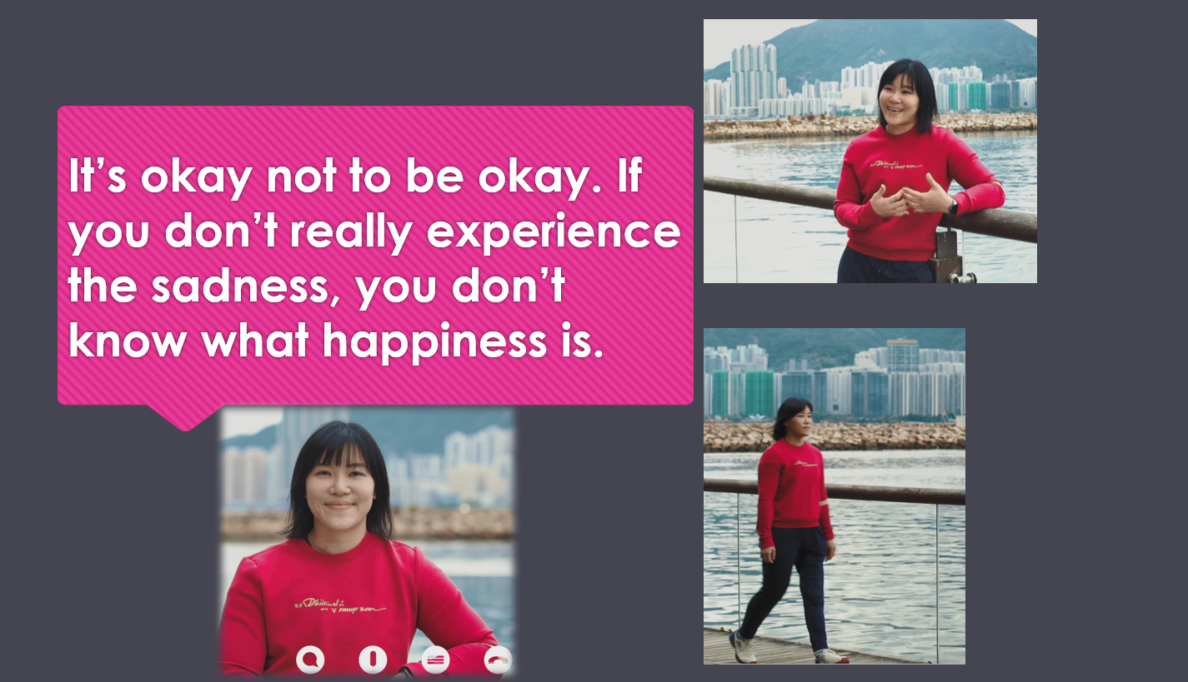
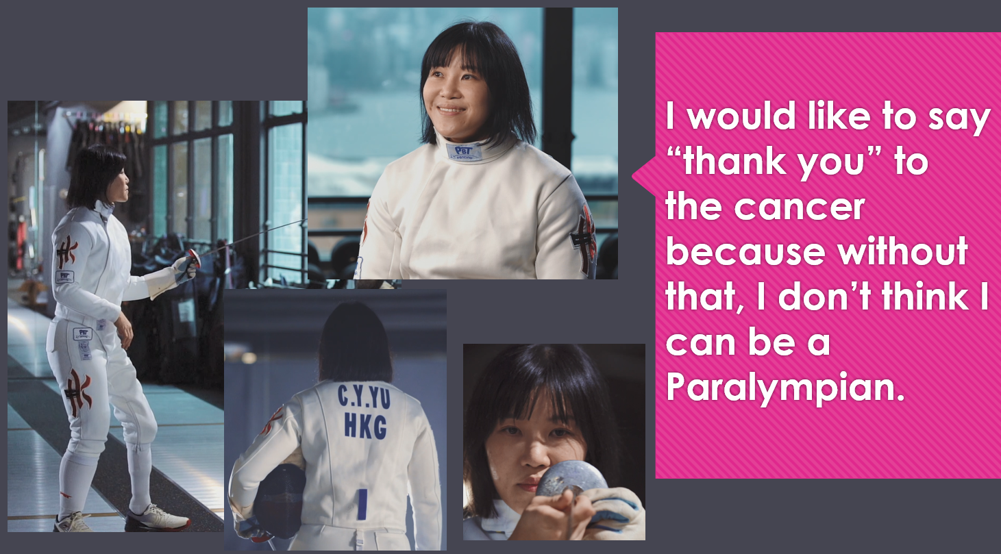
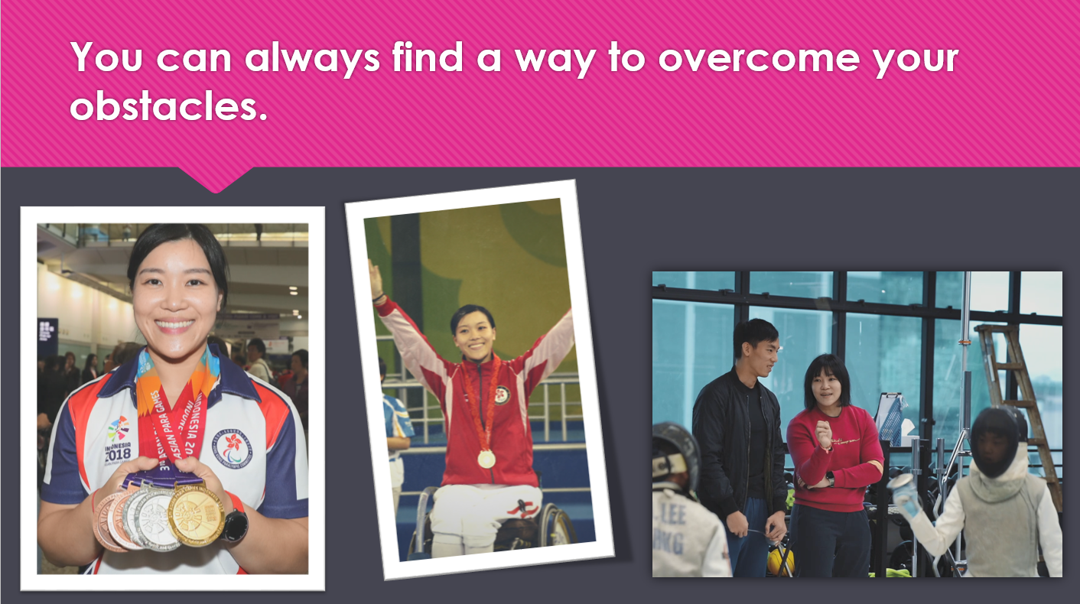

Part 4

Suggested Answers

Fantastic People – Professor Sung Jao Yiu Joseph
(Suggested Answers)

(Pre-viewing)

Part A: Making predictions about the character
1. You are going to watch an interview and know more about Professor Sung Jao Yiu, Joseph. Have you heard of him before? Look at the picture below.
(Accept any reasonable answers.)
He is wearing a white coat.
What is Prof Sung wearing?

He is a doctor.
What is his job?

Professor Sung
What does he do in his job?

He treats people who are ill or suffer from health problems.

2. List three qualities a person needs in order to be a doctor:
(Accept any reasonable answers.)
Be knowledgeable to cure people with illnesses/sickness;
Be kind and caring to patients;
Be diligent to study hard and equip oneself;
Be committed to serving the community and people in need;
Be perseverant to achieve goals and cope with challenges.
(Viewing)

Part B: Understanding the background and achievements of Prof Joseph Sung
3. Watch the video and complete the chart below.
Prof Joseph Sung

Achievements

Education

- Studied at Queen’s College
- Liked Physics because the teachers
were fantastic
- Liked Biology because it was interesting to do little dissections, such as dissecting earthworms, rats and also cockroaches.
1984 Graduated from a medical school.

2002 Achieved groundbreaking discovery of using an antibiotic to cure Helicobacter pylori infection in the stomach

2003 Hailed as an “Asian Hero” by Time Magazine for his contribution during the epidemic

Quotes

- “Becoming a doctor, looking after the poor and the sick, is the part of my career that I’m most proud of.”
- “Challenge means that you go into uncharted waters, but this is the time that you will learn new lessons.”
- “There is no shortcut to success. Hard work will bring you success.”
Challenges

- In Year 2003, a disease called SARS hit Hong Kong. In the period of six months, doctors and patients faced life-and-death situations. Prof Sung provided the medical staff with all the necessary protection before sending them into the war zone. He also faced the challenges with his teammates.
2004 Awarded Silver Bauhinia Star
(Post-viewing)

Part C: Self-reflection

4. Why did Prof Sung like to be a doctor the most?

Prof Sung was proud to be a doctor because he could look after the poor and the sick, and this was the part of his career that he was most proud of. Being a good doctor, he thinks it is more than giving medicine to the patients, but also to care about them and to keep their dignity.

5. According to Prof Sung, what does challenge mean?

Challenge means going into uncharted waters. We may not know how to deal with the difficulties and we feel a bit uncomfortable to face the situations.

However, it is the time that we will learn new lessons. We may succeed or fail. After all, it always brings good lessons.

(Accept any reasonable answers.)

6. What have you learnt from Prof Sung?

I have learnt from Prof Sung that if I want to achieve my goal, hard work and perseverance are important.

I have also learnt that when there is a challenge, it is an opportunity for me to learn new lessons. I should stay strong and face the challenge together with my teammates or family.

7. You have seen Prof Sung visiting his alma mater. In your opinion, how does Prof Sung feel towards his alma mater? Refer to the images below and share your ideas.

(Image taken from the video: 1:05)  Prof Sung is showing his school report. | (Image taken from the video: 1:29)  Prof Sung is walking and chatting with some students on the school lawn.
(Image taken from the video: 4:00)  Prof Sung is demonstrating Chinese calligraphy. | (Image taken from the video: 5:49)  The students are interviewing Prof Sung.

Prof Sung has a deep affection for his alma mater. He is grateful to his teachers and his school/Queen’s College, where he spent his secondary school days. His academic results/school work improved greatly from Form 1 to Form 5, with his best results in the final year. He told us about his fantastic Physics teachers and Biology lessons and experiments. He cherishes them very much. He was generous to share his life experience with the youngsters. He talked about the attitude to face challenges and the key to success in order to encourage them to solve problems with positive attitudes and perseverance.
8. Prof Sung brought us to Prince of Wales Hospital and we could see him at work. Moreover, he has many great achievements. What do you think of Prof Sung? Refer to the images below and share your ideas.
(Accept any reasonable answers.)

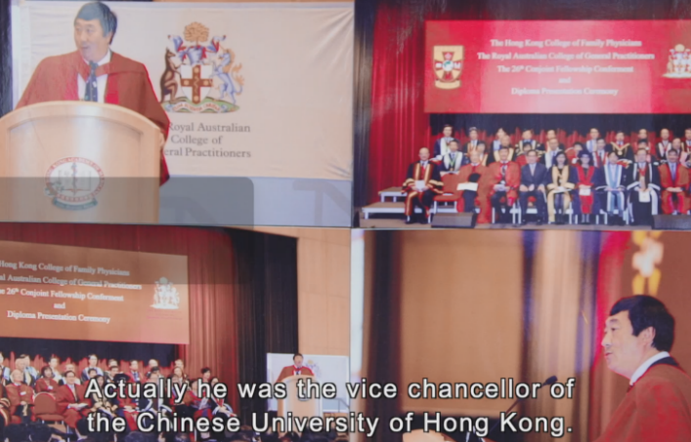 | 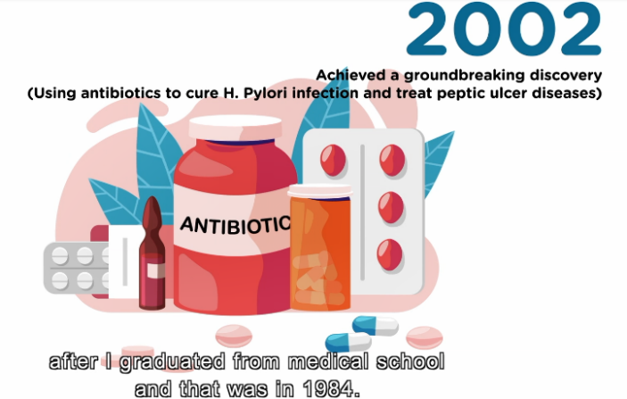
(Image taken from the video: 1:48)  Prof Sung was the Vice-chancellor and President of the Chinese University of Hong Kong. | (Image taken from the video: 2:22)  His groundbreaking discovery of treating Helicobacter pylori infection and peptic ulcer diseases.
(Image taken from the video: 2:26)  He led a team of medical staff to fight the SARS epidemic in 2003. | (Image taken from the video: 2:31)  He was awarded the Silver Bauhinia Star in 2004.

Prof Sung is a great scholar and leader. As a doctor and researcher, he led his team of medical staff in research. When he faced challenges, e.g. the unknown SARS virus, life-and-death situations, he learnt new lessons and did not give up. In 2003, SARS first broke out in the hospital ward under his charge. He was very brave and led his team to combat SARS. He gave full protective gear to his team before sending them into the war zone. From these, we can see that Prof Sung is very knowledgeable in medical research, and very caring to his medical team and patients. He is a great leader and has high achievements.
(Accept any reasonable answers.)
9. Prof Sung is now working at Nanyang Technological University in Singapore. Write a card to send your greeting and express your gratitude to him in 80 – 100 words. (Accept any reasonable answers.)

The greeting:  (e.g. I’m a primary five student studying at ABC School. I’m writing to send my best wishes to you.) | The part(s) of the video that touched you most:  (e.g. I’ve watched a video about you recently and your sharing about how you faced challenges touched me most.)
Your gratitude to Prof Sung  (e.g. I’d like to thank you for your sharing and encouragement to youngsters.) | The positive messages you have learnt from  Prof Sung:  (e.g. I’ve learnt that I should face difficulties with courage and diligence.)

SOWIT Video Series – “Never Look a Gift Horse in the Mouth”
(Video link: www.edb.gov.hk/sowit_horse)

Lesson Plan
Fantastic People – Dr Allan Zeman
(Suggested Answers)

(Pre-viewing)

Part A: Making predictions about the character
1. You are going to watch an interview and know more about Dr Allan Zeman. Have you heard of him before? Look at the picture below.
(Accept any reasonable answers.)
He is wearing a suit.
What is Dr Zeman wearing?

He is a businessman.
What is his job/career?

He sells products/runs business/businesses.
What does he do in his job/career?
a

Dr Zeman

2. List three qualities a person needs in order to be a businessman/an entrepreneur:
(Accept any reasonable answers.)
- Be smart;
- Be hardworking;
- Be familiar with the business that he/she runs;
- Be creative to solve problems;
- Be friendly/ have good social skills.

(Viewing)

Part B: Understanding the background and achievements of Dr Allan Zeman
3. Watch the video and complete the chart below.

Dr Allan Zeman
Early Life

7 years old: Dr Zeman’s father/dad died
19 years old: went to Hong Kong and made a million US dollars profit
16 years old: bought his own car
12 years old: worked in a restaurant cleaning tables
10 years old: delivered newspapers before school

Achievements

- Awarded the Gold Bauhinia Star in 2004
- Awarded the Grand Bauhinia Medal in 2011

Challenges

- Became the chairman of Ocean Park
- Ran around the world, looked at different parks and looked at ideas
- Figured out how to make Ocean Park world-class with the designers
- Kept the park open while upgrading the park
- Changed all the uniform for all the staff
Quotes

- “Don’t just look at what you see. Think beyond. Think how this can be a success.”
- “A successful entrepreneur is someone who is open-minded, has great dreams and makes the dreams a reality.”
- “Always look forward and then bring everybody along with you. Be approachable. I’m everybody’s friend.”
(Post-viewing)

Part C: Self-reflection
4. What does ‘success’ mean to Dr Zeman?

- Success is having an idea, having a dream, looking at something and then making it a reality.
- Doing something that you really have a passion for.
- There are opportunities for everyone as long as you use your mind and as long as you follow your dream.

6. What does ‘success’ mean to you? Do you have any dreams?
(Accept any reasonable answers.)
5. According to Dr Zeman, what are the qualities of a successful entrepreneur?

- You need to have confidence in yourself.
- Don’t look at things for what they are. Look at things for what they could be.
- Think beyond. Think how you can make this into something special.
7. Dr Zeman is a successful entrepreneur and has been awarded the Gold Bauhinia Star and the Grand Bauhinia Medal for his contributions to Hong Kong. What are the factors that make him so successful? Refer to the images below and share your ideas.
(Accept any reasonable answers.)
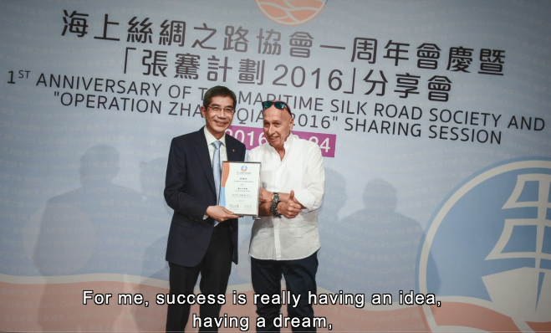
(Image taken from the video: 0:41)  Dr Zeman shares how to become a successful person. | (Image taken from the video: 1:29)  Dr Zeman is talking about his early life in Canada.
 | 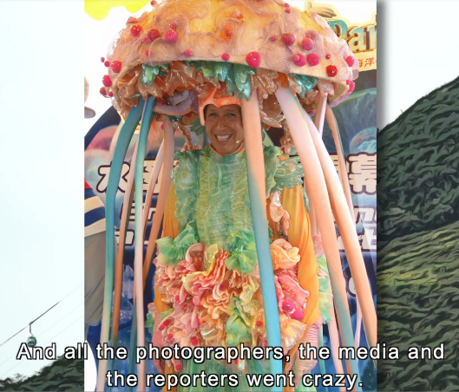
(Image taken from the video: 3:39)  He is talking about his business in Lan Kwai Fong. | (Image taken from the video: 5:45)  Dr Zeman is in a jellyfish costume to promote Ocean Park.

Dr Zeman is a successful businessman and entrepreneur. In his youth, he bravely overcame adversities and was hardworking. To earn money for his family, when he was 10 years old, he delivered newspapers before school. When he was 12, he worked in a restaurant on the weekends cleaning tables. He is very talented as a businessman. At 19, he made a million US dollars profit.

Dr Zeman is famous for turning Lan Kwai Fong into a world-famous entertainment and bar and night life district. He is open-minded, has great dreams, and makes the dreams a reality. He is a good leader. He could bring his staff and co-workers along with him. He is forward-looking and creative.

He was the chairman of Ocean Park and tried to make Ocean Park world-class. He looks beyond things, explores what they could be, and turns them into something special. He uses his mind and takes/grasps the opportunities that come his way. He has a passion for what he is doing, and has confidence in himself. He is also very approachable and friendly. These make him successful.

8. What do you want to do in the future? What is your dream job? Write about your dream job in 80 –100 words. Share it with your classmates. (Accept any reasonable answers.)
What is your dream job? Why do you like this job?  (e.g. I want to be a vet in the future because I love animals.) | What do you need to do?  (e.g. I have to diagnose the illnesses of different types of animals and I may have to do surgery for them.)
What will you do to achieve your goal?  (e.g. To achieve my goal, I will have to work hard and read more books and information about animals, e.g. on animal care, illnesses and treatment.) | What qualities does a person need to have in order to be successful in that area?  (e.g. To be a successful vet, I need to be kind-hearted and knowledgeable.)

_________________________________________________________________
_________________________________________________________________
_________________________________________________________________
_________________________________________________________________
_________________________________________________________________
_________________________________________________________________
_________________________________________________________________
_________________________________________________________________
_________________________________________________________________
_________________________________________________________________
_________________________________________________________________
_________________________________________________________________
_________________________________________________________________
_________________________________________________________________

Fantastic People – Ms Yu Chui Yee, Alison
(Suggested Answers)
(Pre-viewing)

Part A: Making predictions about the character
1. Look at the picture below. Have you heard of Ms Yu Chui Yee, Alison? Can you guess what is very special about her? (Accept any reasonable answers.)
She does fencing.
What sports does Alison play?

She is a wheelchair fencer / an athlete.
What is her job?

Because her leg was hurt.
Why does she sit in a wheelchair?

2. List three qualities a person needs in order to be an athlete:
(Accept any reasonable answers.)
- Be talented in doing sports;
- Set clear goals;
- Be humble to accept advice and instructions from the coach;
- Follow a tight training schedule to strengthen his/her physical fitness;
- Be brave, confident and determined to win in competitions.

(Viewing)

Part B: Understanding the background and achievements of Ms Alison Yu
3. Watch the video and complete the chart below.

Achievements

- Awarded the Bronze Bauhinia Star
- Received Hong Kong Sports Stars Award 7/seven times
- Won 11/eleven Paralympic medals

Childhood

- Loved sports, e.g. playing badminton and swimming
- Got bone cancer when she was 11 years old

Ms Alison Yu
Quotes

- “It’s okay not to be okay. If you don’t really experience the sadness, you don’t know what happiness is.”
- “I would like to say ‘thank you’ to the cancer because without that, I don’t think I can be a Paralympian.”
- “You can always find a way to overcome your obstacles.”
Challenges

- Got bone cancer
- Had to amputate her left leg
- Learn to be friends with the prosthesis

Ways to release stress

- Eating something good
- Doing sports
- Listening to music

(Post-viewing)

Part C: Self-reflection
(Accept any reasonable answers.)
4. What adjectives would you use to describe Alison? Why? (e.g. optimistic, positive, out-going, cheerful, etc.)

(Accept any reasonable answers.)
5. What have you learnt from Alison?

6. We face different challenges every day and may feel stressful sometimes. It is important to find ways to release our stress.
a) Tick the challenges that you are facing.
b) Write down the things you do to help you release stress in the balloons below and share them with your classmates.
(Accept any reasonable answers.)
school work
friendship

competitions
examinations
parents’ expectation
illnesses
I can talk to my parents if their expectations on me are too high.
To help me release my stress from the examinations, I will do some exercise.
To cope with tests, I can set a timetable and do revision bit by bit.
To help me feel relaxed before the competitions, I will listen to music.

7. Being a professional athlete requires years of disciplined practice, as well as perseverance and determination. In your opinion, what makes Alison such a fantastic person? Refer to the images below and share your ideas. (Accept any reasonable answers.)
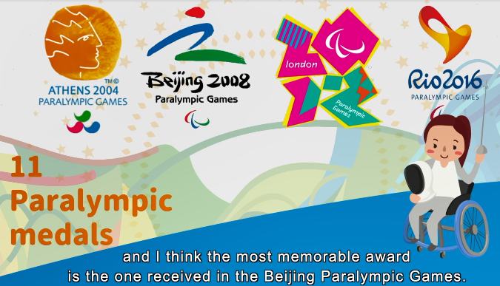 | 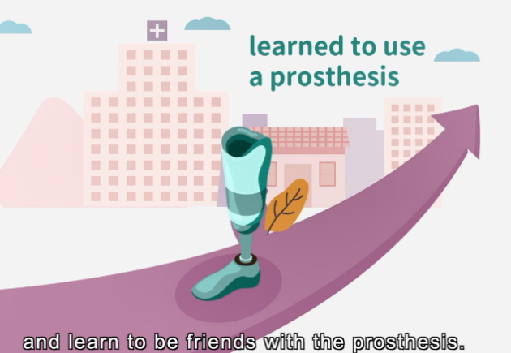
(Image taken from the video: 0:53)  Alison received Hong Kong Sports Stars Awards seven times and won 11 Paralympic medals. | (Image taken from the video: 2:27)  She had bone cancer at 11 years old and had to amputate her left leg.
 | 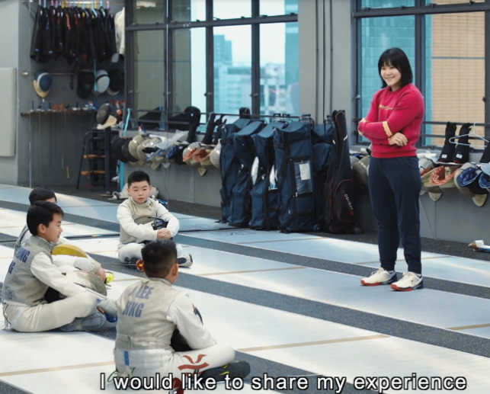
(Image taken from the video: 4:13)  She shared her life motto that “It’s okay not to be okay”. | (Image taken from the video: 5:30)  She shared that when she retired, she would try to contribute more to the Paralympic movement and to Hong Kong society.

When Alison had bone cancer at 11 and had to amputate her left leg, she stayed positive and optimistic and learnt to start a new life and be friends with the prosthesis. On looking back/ In retrospection, she considers her disability a ticket for her to compete in the Paralympic Games. Her life motto is “It’s okay not to be okay”. If one does not experience something bad, one doesn’t know what happiness is. She copes with her pressure and relaxes by doing things she likes. She also greatly cherishes the support from her parents, friends, coaches and teammates. Also, Alison has great achievements in sports and contribution to society, e.g. in the Paralympic movement, promoting equal opportunities. All these make her a fantastic person.

8. What made you feel very stressful? How did you cope with stress? How did you feel at last? What have you learnt from the experience? Think of one incident and write a journal in 80-100 words. (Accept any reasonable answers.)
What made you feel stressful?  (e.g. The badminton competition made me very stressful.) | How did you cope with stress and solve the problem?  (e.g. To cope with stress, I listened to music and talked to my friends. I also set a reasonable timetable and practise more.)
What have you learnt from the experience?  (e.g. I have learnt that I have to find ways to release my stress. Also, I found that stress can be the driving force which motivates me to do better.) | How did you feel at last?  (e.g. I felt relaxed at last.)

Journal Writing
Date: ____________________
Weather: ____________________
Topic:
Ways to cope with stress:
SOWIT Video Series – “Rome was not Built in a Day”
My drawing/notes:

(Blank Page)
_________________________________________________________________
_________________________________________________________________
_________________________________________________________________
_________________________________________________________________
_________________________________________________________________
_________________________________________________________________
_________________________________________________________________

